SCENARIO 1:

Before Running lambda function:

SNAPSHOT AVAILABLE BEFORE:

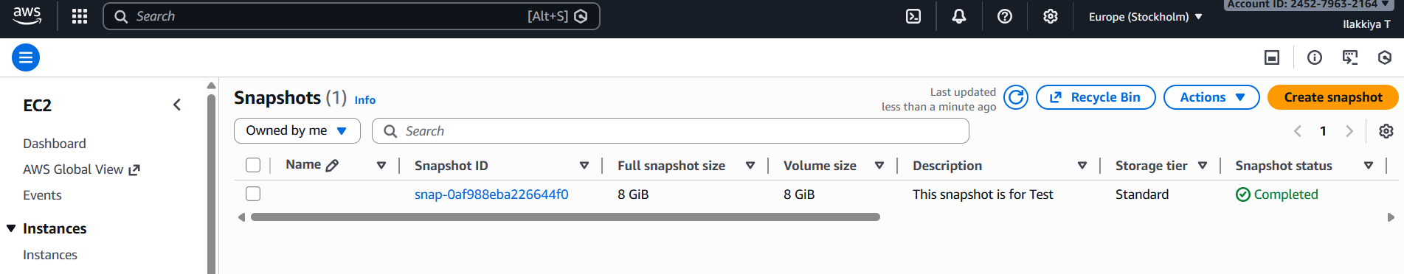

AFTER IMPLEMENTING LAMBDA FUNCTION:

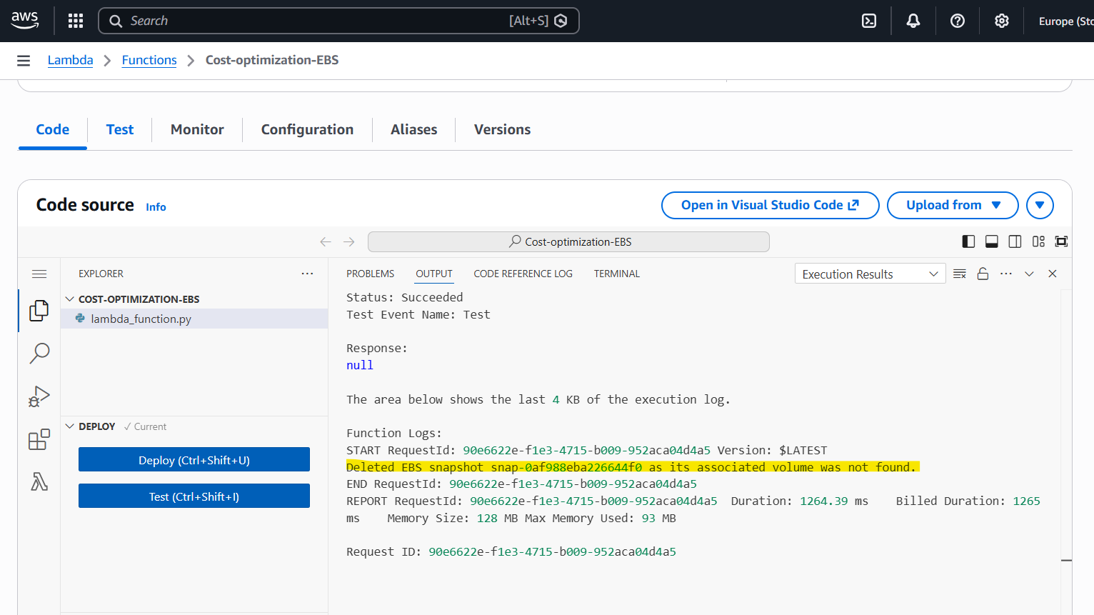
SCENARIO 2:

Created a EBS volume and created a snapshot from it:

After running lambda function, snapshot got deleted as the ebs voume is not attached to any one of the ec2 instances.

